class Cm1 {

public static void main(String[] args) {

double a=2.54;

System.out.println("centimeter = " + Float.parseFloat(args[0])\*2.54);

}

}

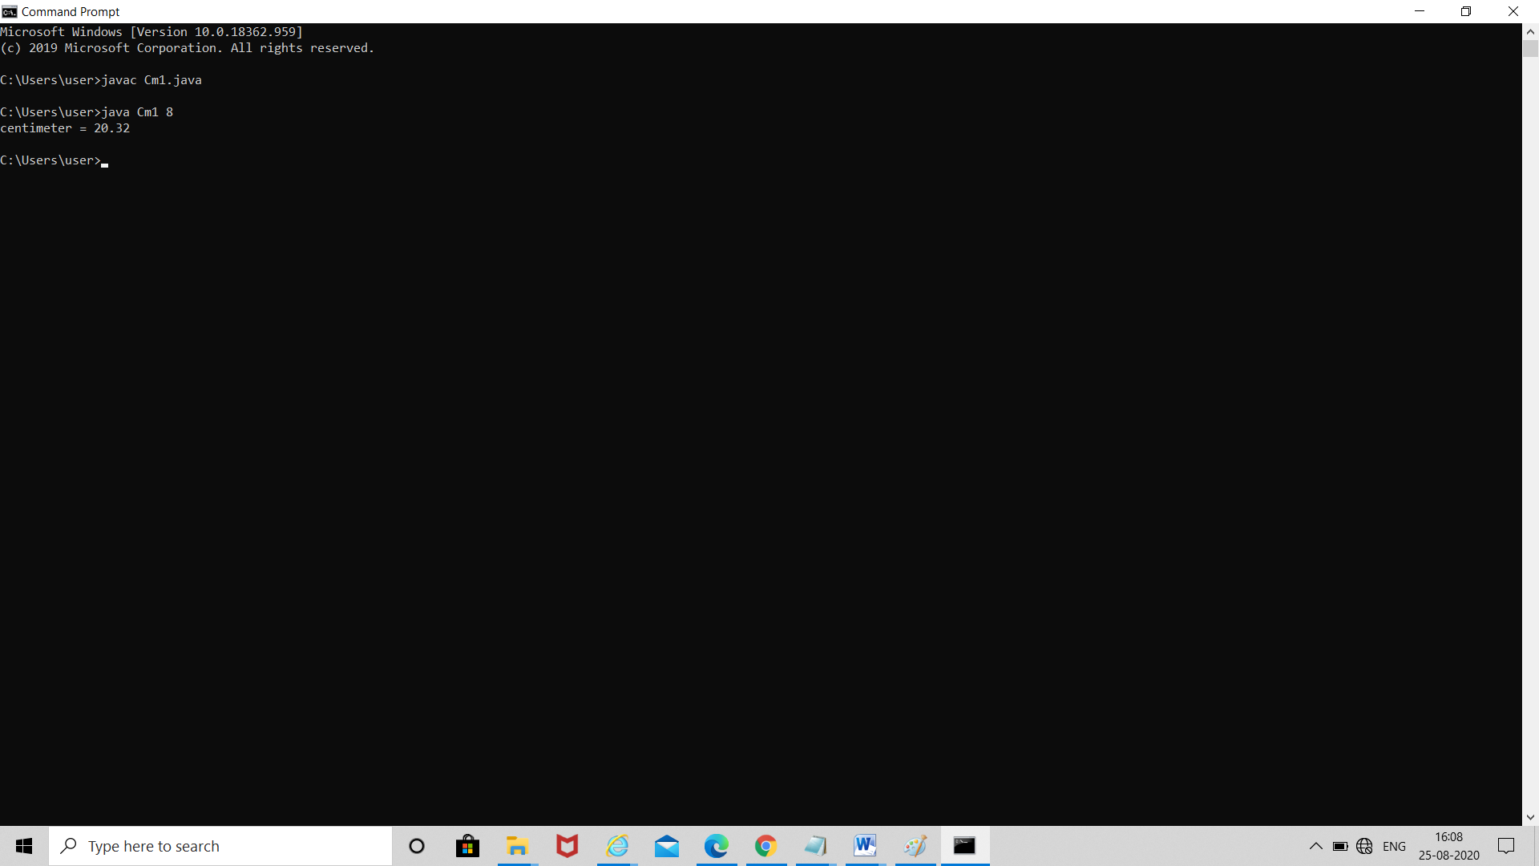v